**Name :** Muhammad Khubaib

**Python Programing Assignment**

**Assignment#2**

**Question 1: Variables and Data Types Write a Python program that:**

1. Accepts a string, an integer, a float, and a boolean from the user.

2. Initializes variables for each type and prints them out.

3. Converts the string to uppercase and prints it.

4. Checks if the integer is even or odd and prints the result.

5. Multiplies the float by 2 and prints the result.

Ans:

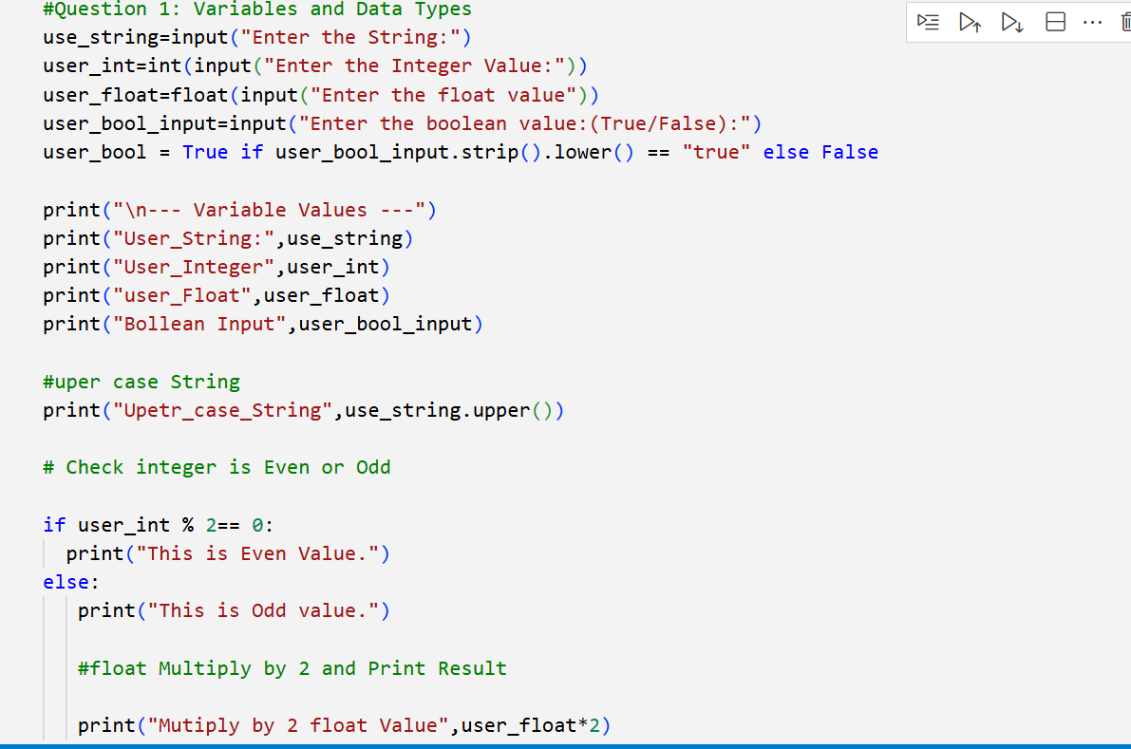

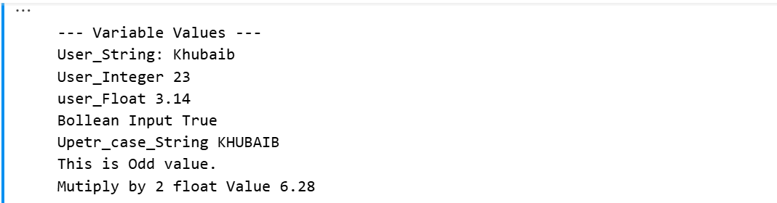

Question 2: Operators Arithemtic Logic or Camerision

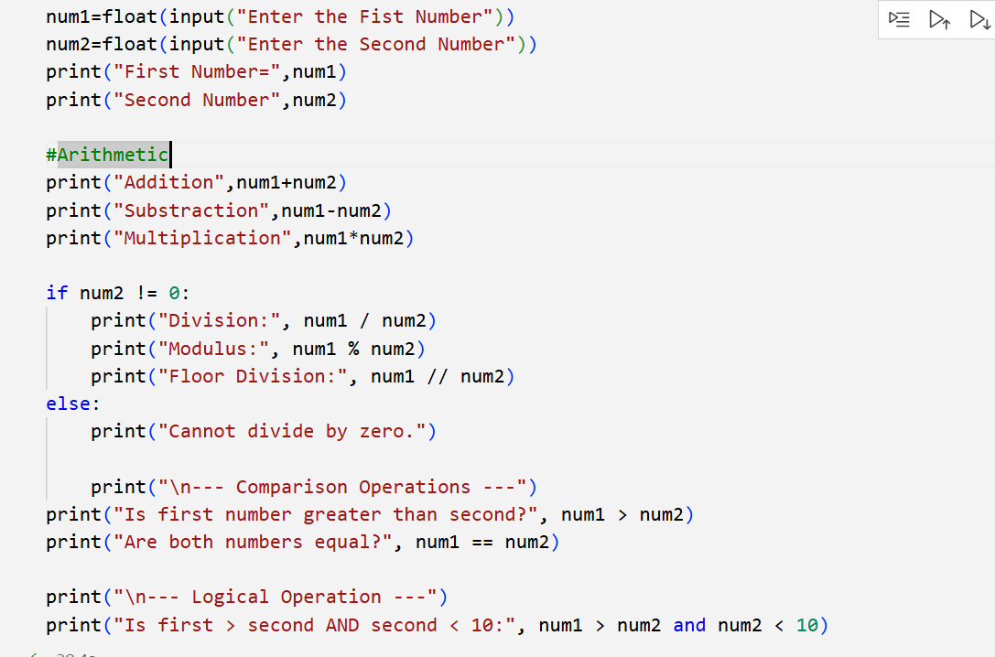

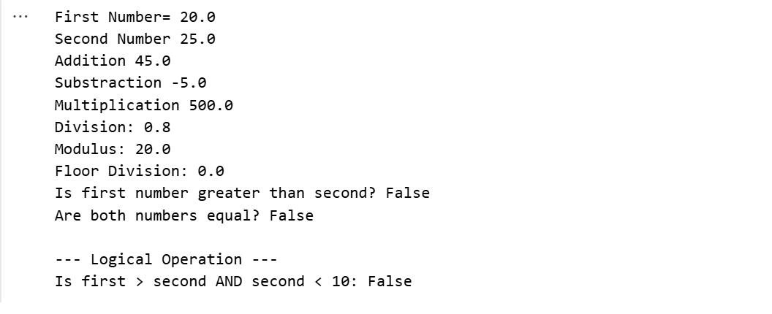

Question 3: Loops